Module 1.
Introducing Continuous Delivery

Understanding CD
"Continuous delivery is the ability to get changes of all types – including new features, configuration changes, bug fixes, and experiments – into production, or into the hands of users, safely and quickly, in a sustainable way."

The traditional delivery process

Introducing the traditional delivery process

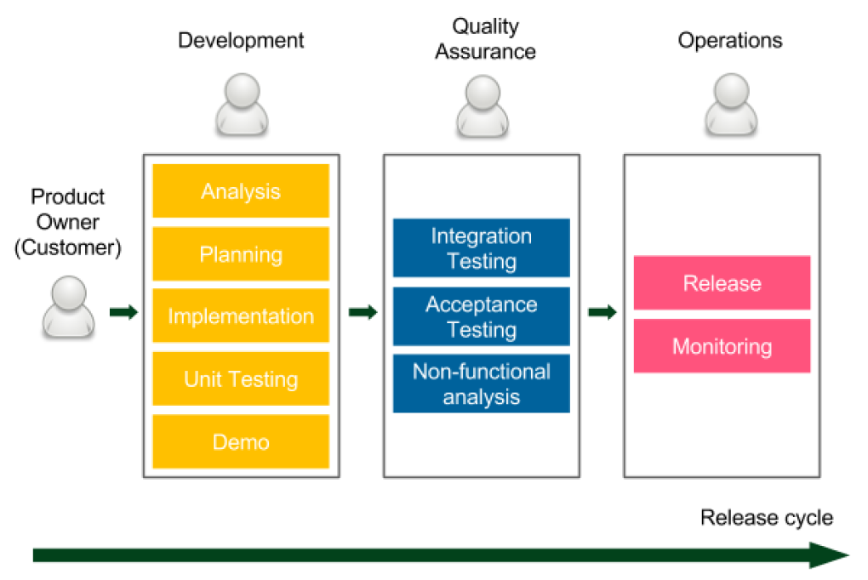

Figure 1 – Release cycle diagram

The release cycle starts with the requirements provided by the Product Owner, who represents the Customer (stakeholders). Then, there are three phases, during which the work is passed between different teams:

- Development: The developers (sometimes together with business analysts) work on the product. They often use agile techniques (Scrum or Kanban) to increase the development velocity and improve communication with the client. Demo sessions are organized to obtain a customer's quick feedback. All good development techniques (such as test-driven development (TDD) or extreme programming practices) are welcome. Once the implementation is complete, the code is passed to the QA team.

- Quality Assurance: This phase is usually called User Acceptance Testing (UAT) and it requires the code to be frozen on the trunk code base so that no new development will break the tests. The QA team performs a suite of integration testing, acceptance testing, and non-functional analysis (performance, recovery, security, and so on). Any bug that is detected goes back to the development team, so the developers usually have their hands full. After the UAT phase is completed, the QA team approves the features that have been planned for the next release.

- Operations: The final phase, and usually the shortest one, involves passing the code to the operations team so that they can perform the release and monitor the production environment. If anything goes wrong, they contact the developers so that they can help with the production system.

Shortcomings of the traditional delivery process

- Slow delivery: The customer receives the product long after the requirements were specified. This results in unsatisfactory time to market and delays customer feedback.

- Long feedback cycle: The feedback cycle is not only related to customers but developers. Imagine that you accidentally created a bug, and you learn about it during the UAT phase. How long does it take to fix something you worked on 2 months ago? Even dealing with minor bugs can take weeks.

- Lack of automation: Rare releases do not encourage automation, which leads to unpredictable releases.

- Risky hotfixes: Hotfixes cannot usually wait for the full UAT phase, so they tend to be tested differently (the UAT phase is shortened) or not tested at all.

- Stress: Unpredictable releases are stressful for the operations team. What's more, the release cycle is usually tightly scheduled, which imposes additional stress on developers and testers.

- Poor communication: Work that's passed from one team to another represents the waterfall approach, in which people start to care only about their part, rather than the complete product. If anything goes wrong, that usually leads to the blame game instead of cooperation.

- Shared responsibility: No team takes responsibility for the product from A to Z:
  - For developers: Done means that the requirements have been implemented.
  - For testers: Done means that the code has been tested.
  - For operations: Done means that the code has been released.

- Lower job satisfaction: Each phase is interesting for a different team, but other teams need to support the process. For example, the development phase is interesting for developers but, during the other two phases, they still need to fix bugs and support the release, which is usually not interesting for them at all.

The benefits of CD
CD is all about changing each phase of the traditional delivery process into a sequence of scripts called the automated deployment pipeline, or the CD pipeline.

CD lets us get rid of the tedious release cycle and brings the following benefits:

- Fast delivery: Time to market is significantly reduced as customers can use the product as soon as development is completed. Remember that the software delivers no revenue until it is in the hands of its users.

- Fast feedback cycle: Imagine that you created a bug in the code, which goes into production the same day. How much time does it take to fix something you worked on the same day? Probably not much. This, together with the quick rollback strategy, is the best way to keep production stable.

- Low-risk releases: If you release daily, the process becomes repeatable and much safer.

- Flexible release options: If you need to release immediately, everything is already prepared, so there is no additional time/cost associated with the release decision.

Success stories

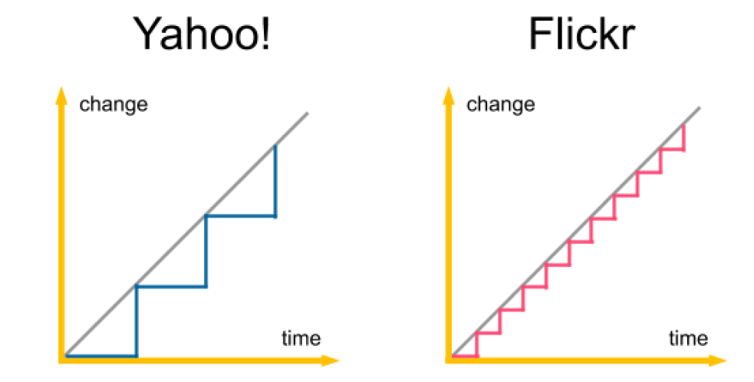

Figure 2 – Comparison of the release cycles of Yahoo! and Flickr

A release is less risky if the following is true:

- The delta of code changes is small
- The process is repeatable

That is why, even though the release itself is a difficult activity, it is much safer when it's done frequently.

Keep in mind that the statistics get better every day. However, even without any numbers, just imagine a world in which every line of code you implement goes safely into production. Clients can react quickly and adjust their requirements, developers are happy as they don't have to solve that many bugs, and managers are satisfied because they always know the current state of work. After all, remember that the only true measure of progress is the software that is released.

The automated deployment pipeline

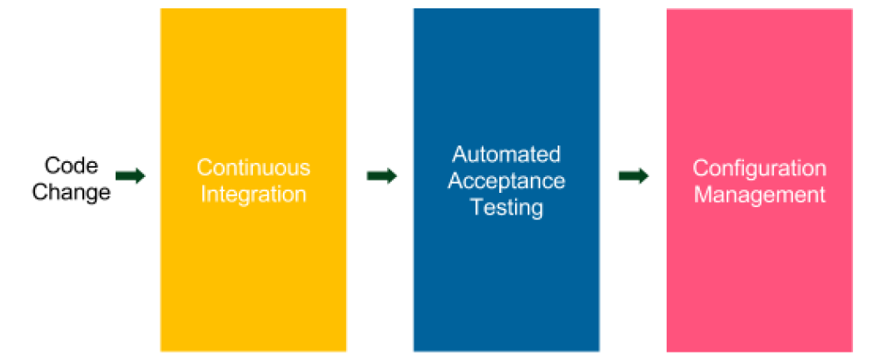

Figure 3 – Automated deployment pipeline

The automated deployment pipeline is a sequence of scripts that is executed after every code change is committed to the repository. If the process is successful, it ends up being deployed to the production environment.

Each step corresponds to a phase in the traditional delivery process, as follows:

- Continuous integration: This checks to make sure that the code that's been written by different developers is integrated.

- Automated acceptance testing: This checks if the client's requirements have been met by the developers implementing the features. This testing also replaces the manual QA phase.

- Configuration management: This replaces the manual operations phase; it configures the environment and deploys the software.

Continuous integration
The continuous integration (CI) phase provides the first set of feedback to developers. It checks out the code from the repository, compiles it, runs unit tests, and verifies the code's quality. If any step fails, the pipeline's execution is stopped and the first thing the developers should do is fix the CI build. The essential aspect of this phase is time; it must be executed promptly.

The CI pipeline is usually the starting point. Setting it up is simple because everything is done within the development team, and no agreement with the QA and operations teams is necessary.

Automated acceptance testing
The automated acceptance testing phase is a suite of tests written together with the client (and QAs) that is supposed to replace the manual UAT stage. It acts as a quality gate to decide whether a product is ready to be released. If any of the acceptance tests fail, pipeline execution is stopped and no further steps are run. It prevents movement to the configuration management phase and, hence, the release.

The whole idea of automating the acceptance phase is to build quality into the product instead of verifying it later. In other words, when a developer completes the implementation, the software is delivered together with the acceptance tests, which verify that the software is what the client wanted. That is a large shift in thinking concerning testing software. There is no longer a single person (or team) who approves the release, but everything depends on passing the acceptance test suite. That is why creating this phase is usually the most difficult part of the CD process. It requires close cooperation with the client and creating tests at the beginning (not at the end) of the process.

Configuration management
The configuration management phase is responsible for tracking and controlling changes in the software and its environment. It involves taking care of preparing and installing the necessary tools, scaling the number of service instances and their distribution, infrastructure inventory, and all the tasks related to application deployment.

Building the CD process

Introducing tools

The Docker ecosystem
Docker, as the clear leader of the containerization movement, has dominated the software industry in recent years. It allows us to package an application in an environment-agnostic image and treats servers as a farm of resources, rather than machines that must be configured for each application. It fits the (micro) service world and the CD process.

Docker entails several additional technologies, as follows:

- Docker Hub: This is a registry for Docker images
- Kubernetes: This is a container orchestrator

Jenkins
Jenkins is by far the most popular automation server on the market. It helps create CI and CD pipelines and, in general, any other automated sequence of scripts. Highly plugin-oriented, it has a great community that constantly extends it with new features. What's more, it allows us to write the pipeline as code and supports distributed build environments.

Ansible
Ansible is an automation tool that helps with software provisioning, configuration management, and application deployment. It is trending faster than any other configuration management engine and will soon overtake its two main competitors: Chef and Puppet. It uses an agentless architecture and integrates smoothly with Docker.

GitHub
GitHub is the best of all hosted version control systems. It provides a very stable system, a great web-based UI, and a free service for public repositories. Having said that, any source control management service or tool will work with CD, irrespective of whether it's in the cloud or self-hosted, and whether it's based on Git, SVN, Mercurial, or any other tool.

Java/Spring Boot/Gradle
Java has been the most popular programming language for years. Together with Java, most companies develop with the Spring framework. Gradle is used as a build tool. It's still less popular than Maven, but it's trending much faster.

The other tools
Cucumber was chosen arbitrarily as the acceptance testing framework. Other similar solutions are FitNesse and Jbehave. For the database migration process, we will use Flyway, but any other tool would do, such as Liquibase.

Creating a complete CD system

Introducing Docker

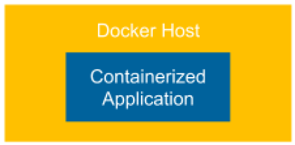

Figure 4 – Introducing Docker

A dockerized application (web service) is run as a container on a Docker Host and is reachable as it will run directly on the host machine.

Configuring Jenkins
Thanks to the support of multiple agent (slave) nodes, it can handle the heavy concurrent load.

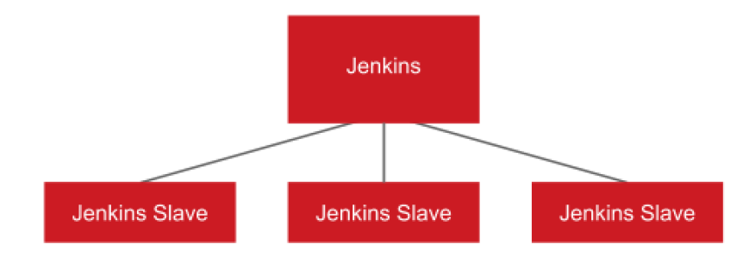

Figure 5 – Configuring Jenkins

The CI pipeline

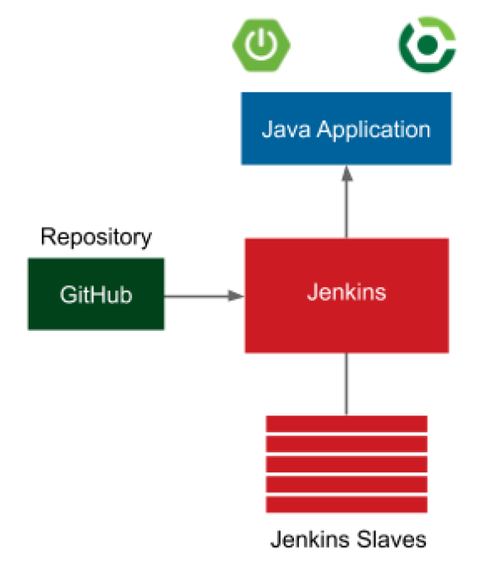

Figure 6 – The CI pipeline

The application is a simple web service written in Java with the Spring Boot framework. Gradle is used as a build tool and GitHub is used as the source code repository. Every commit to GitHub automatically triggers the Jenkins build, which uses Gradle to compile Java code, run unit tests, and perform additional checks (code coverage, static code analysis, and so on). Once the Jenkins build is complete, a notification is sent to the developers.

Automated acceptance testing

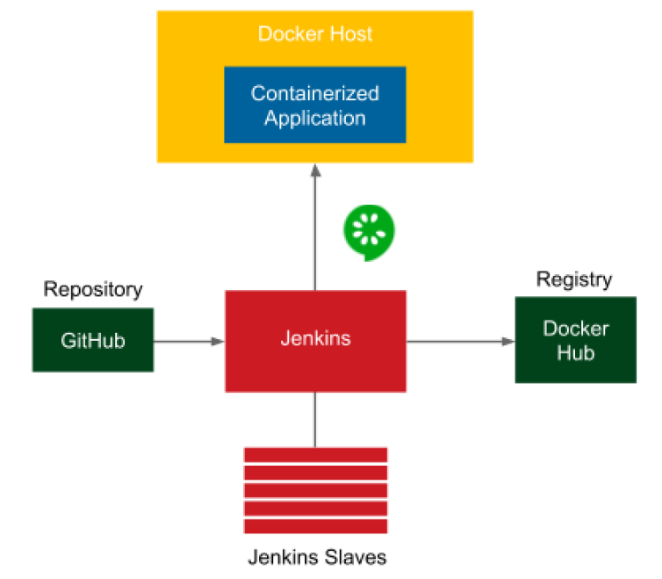
Figure 7 – Automated acceptance testing

The additional elements in the preceding diagram are related to the automated acceptance
testing stage:

- Docker Registry: After the CI phase, the application is packaged into a JAR file and then as a Docker image. That image is then pushed to the Docker Registry, which acts as storage for dockerized applications.

- Docker Host: Before performing the acceptance test suite, the application must be started. Jenkins triggers a Docker Host machine to pull the dockerized application from the Docker Registry and starts it.

- Cucumber: After the application is started on the Docker Host, Jenkins runs a suite of acceptance tests written in the Cucumber framework.

Clustering with Kubernetes

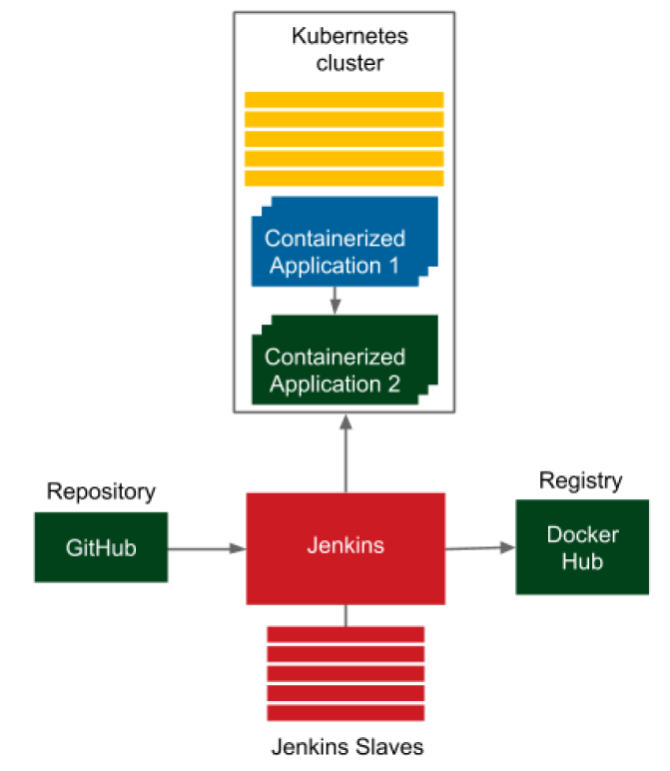
Figure 8 – Clustering with Kubernetes

Kubernetes provides an abstraction layer for a set of Docker hosts and allows simple communication between dependent applications. We no longer have to think about which machine our applications are deployed on. All we care about is the number of instances.

The CD pipeline/advanced CD
We will deploy the application to the staging environment, run the acceptance testing suite, and release the application to the production environment, usually in many instances.

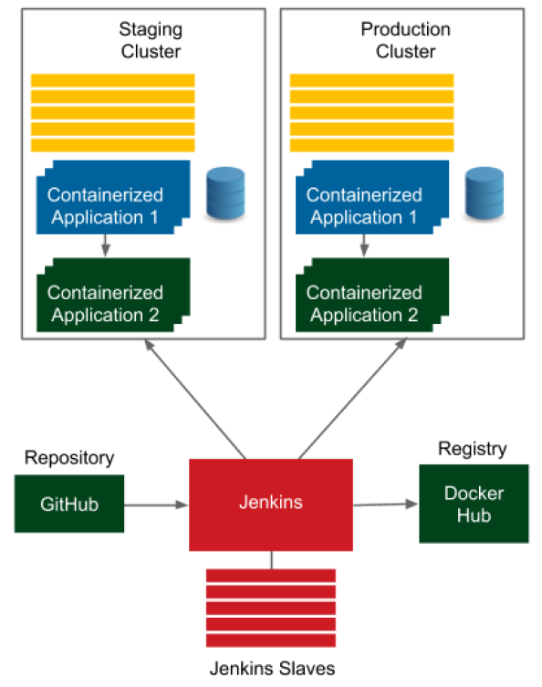
Figure 9 – The CD pipeline/advanced CD

